Coursera Data Science Capstone – Week 4 Report:
The Battle of the Worcester Neighborhoods
1. Introduction:
A description of the background.
In Worcester County, MA. I recently get a dream job in Boylston and the new office is located almost 15 miles away from home. This means my daily travel time is close to 1.5 hours. I am considering moving closer to the office to avoid wasting time. I and my family currently stay in the neighborhood of the city of Worcester, which is in the west of Worcester County, and the job office is in Boylston, which is in the east of Worcester County. Since I don’t have to consider to stay in Boylston where has a relatively high rent price. But I prefer moving to a neighborhood closer to my workplace and similar to our current neighborhood of Worcester.
A discussion of the problems.
•
•
Which neighborhoods in Worcester County are good choices for our family to move to?
These candidate neighborhoods should be both close to my new office and
similar to our current living environment.
2. Data and Methodology:
To address this problem, we need:
•
•
Geographical Data of Worcester County neighborhoods - latitude and longitude details
of the cities in Worcester County
Neighborhoods Environment Data - data describing interests and venues within a given
radius
Sources of Data: For the latitude and longitude coordinates of neighborhoods, our primary
source of information is the following Wikipedia page:
https://en.wikipedia.org/wiki/Worcester_County,_Massachusetts
•
This wiki page comprises a list of links to 60 cities/towns neighborhoods. Each link
contains the latitude and longitude of that particular location. Hence, we can compile a
database of 88 neighborhoods in Worcester County from these wiki pages, using a web-
scraping tool i.e. BeautifulSoup.
•
•
For neighborhood environment details, we use the Foursquare database. Since we are
interested in the character and composition of each neighborhood, we use the ‘explore’
endpoint to learn about the popular venues in each neighborhood.
In the end, we will run an unsupervised k-means clustering model to look for similar
locations as our current neighborhood.

3. Data Description:
We crawled 57 records of cities in the Worcester county with the name of the city and its
geographic location.
Then, from the Foursquare Database, we obtained 461 records of the Neighborhoods
Environment Data – the data describing interests and venues within a given radius (10km) of each
city.
We then get the venues for every neighborhood ranked by popularity and proximity.
After grouping by the neighborhood and calculating the mean value each type of venue, we are
able to identify the top ten venues for each neighborhood.
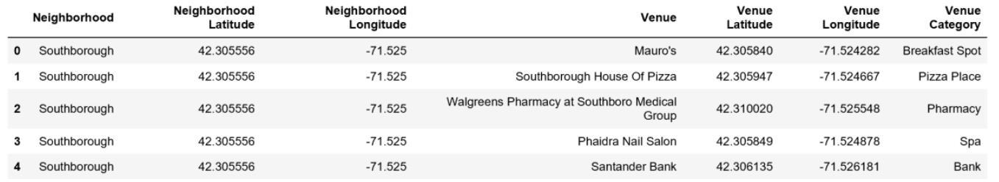
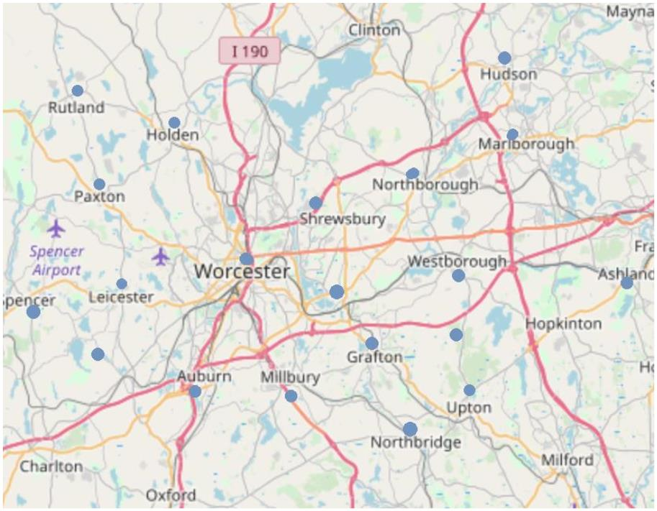
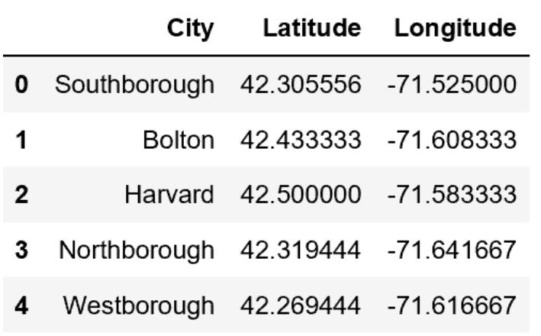

4. Results
In the end, we adopted the K-means Clustering method to group similar neighborhoods, in a hope
of finding a similar neighborhood which locate near Boylston and meanwhile having an identical
nearby venues and interests as Worcester city.
We are able to cluster the 57 cities into 5 groups according to their various characteristics.
We found that Worcester city, where we live in now, is categorized in cluster 4 with the other 10
cities. These are a list of good candidate cities that may meet our criterion.
The neighborhood of Gardner, Petersham, and Warren come closest to our current neighborhood
in terms of nearby venues. But these neighborhoods are still far away from My
workplace. Since our first consideration was to reduce his travel time, we might want to assess a
few more neighborhoods in the same Cluster as Worcester.
